*** iFarmService Easy documentation***

**iFarmService** is an easy to use job scheduling, costing and management system that was designed for the small and medium size farmer. It is rich in functionality and very reasonably priced. ($199 per year). The system was designed to accommodate the individual farmer, farm management companies and community based farmers.

The system is an internet based application that can be used anywhere you have an internet connection. With the new lines of tablet computers you can enter field records in the field or view your profitability from the beach in some tropical paradise.

**iFarmService** provides a great starting point for anyone looking to improve their field records, crop yield and financial performance and gain a detailed understanding of their business. It's easy and powerful

**iFarmService** provides a farm based social network infrastructure. Aside from managing your own business the network will allow you to share ideas and thoughts with other farmers. As the network grows your access to information will grow. As you build relationships your ability to sell, share and exchange equipment, supplies, services and techniques will be enhanced.

**Easy Documentation** - We call the documentation “easy documentation” because it’s easy to read. Lot’s of pictures, not too many words and easy to understand. Not everything requires detail explanation. While rich in functionality the software is simple, elegant and easy to use.

We hope you enjoy it.

***Getting started***

Before we start there are a couple of tidbits of information that you need to understand.

* much of the information you will use is predefined in the “datatype” table.
* When you sign up as a user, a new datatype table is created for you.
* This can be viewed on the “Utility Menu” under data types.
  + Some information in “datatype” can NOT be changed because it is used for decision making in iFarmService. These items are flagged as “is protected”.
  + Other items can be customized by you to adapt to your situation.
* This is a list of the data types and where they are used.

|  |  |  |
| --- | --- | --- |
| **Data type name** | **Usage Description** | **Is protected?** |
| Activity_type | Type of equipment maintenance activity. In equipment definition. | Yes |
| Application_method | How a supply is applied. In supply definition |  |
| Capacity_uom | Unit of measure of capacity for a storage unit |  |
| Contract_uom | Unit of measure for a sales contract |  |
| Crop_grade | Quality grades for crops. In crop inventory |  |
| Crop_inventory_uom | Unit of measures for crop inventory |  |
| Crop_name | List of various crops. Selected in crop definition |  |
| Crop_type | Types of crops. In crop definition. |  |
| Crop_uom | Unit of measure used for crop harvest. In crop definition. |  |
| Current_state | Current state of a field. In field definition |  |
| Distribution_uom | Unit of measure for supply usage. This is converted from the purchase unit of measure. In supply definition. |  |
| Equipment_category | Category of a piece of equipment. In equipment definition. |  |
| Expense_name | Name of an overhead expense item. In Farm definition. |  |
| Expense_type | Type of expense(cash, non cash overhead, interest) . In Farm definition | Yes |
| Farmjob_sort_sequence | Sort sequence for Farm job reports | Yes |
| Holding_status | State the field is held and managed in. In Field definition. | Yes |
| Invoice_number | Invoice number counter. In invoice creation. | Yes |
| Invoice_sort_sequence | Sort sequence used to print invoices. In Print invoices. |  |
| Invoice_status | Status of the invoice | Yes |
| Invoice_terms | Payment terms for an invoice. |  |
| Job_status | Status of a farm job. (Plan, in process, complete) | Yes |
| Payment_terms | Terms set up for a sales contract. |  |
| Payment_type | Payment type for a sales contract. |  |
| Plan_status | Current status for a Crop plan |  |
| Plan_year | Year of a given Crop plan. |  |
| Po_detail_status | Purchase order line item status. | Yes |
| Po_status | Purchase order status. |  |
| Po_type | Purchase order type. In PO definition. |  |
| Profit_reports | Versions of profitability reports | Yes |
| Reprint | Invoice Reprint state | Yes |
| Scaleticket_number | Scaleticket number counter. In scaleticket definition. | Yes |
| Scaleticket_prefix | Prefix for scaleticket number. |  |
| Security_question | Questions and answers used in case you forget your password | Yes |
| Security_question_0 |  |  |
| Seed_rate_land | Land measure used for seed rates. |  |
| Seed_rate_uom | Unit of measure used for seed rates. In crop definition. |  |
| Ship_status | Shipment status. In shipment definition. | Yes |
| Size_uom | Unit of measure for storage area size. In storage area definition. |  |
| Storage_type | Storage area type. In storage area definition |  |
| Supply_carrier | Carrier type used to disberse a supply. In supply definition. |  |
| Supply_type | Types of supplies. In supply definition. |  |
| Supply_uom | Unit of measure used for supply purchases. In supply definition. |  |
| Task_stage | Stage for a field task. Used in profitability reports. | Yes |
| Task_type | Type of field tasks. In Field task definition. |  |
| Weather_segment | Day segment for farm jobs. In farm job definition. |  |
| Wind_direction | Wind direction for farm jobs. In farm job definition |  |

**Grids**

The grid components used in the system are clear, logical and consistent.

* Every feature is entered through a grid view of that particular feature. The grids are powerful and flexible. You can search and filter most components within a grid feature.
* You can sort most columns (by clicking on the header) and use the input boxes to filter particular columns. Some rows can be updated inline. See feature documentation for the specific columns that are available to update.

A Grid example – for crop definition.

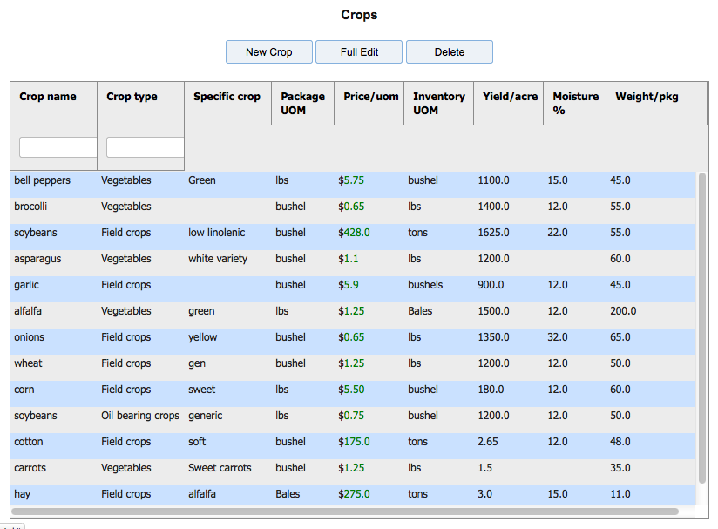

From most grids you have the options to :

Add a new record

Edit an existing record

Delete a record

by selecting the row and clicking the relative button.

**Dates**

All date entry fields will pop up a calendar when you click on the field. To insure correct date format you should use the calendar to select the date.

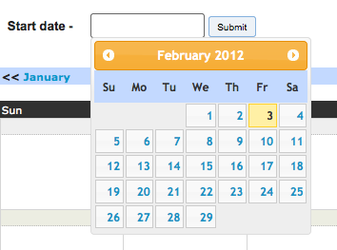

Not too much more to know for now. We’re about ready to get started.

**Let’s start here**

Enter this URL into your web browser.

Ifarmservice.heroku.com (in the future to be www.ifarmservice.com)

Select the “get started with iFarmService” button to continue.



The first thing to do is to sign up as a user.

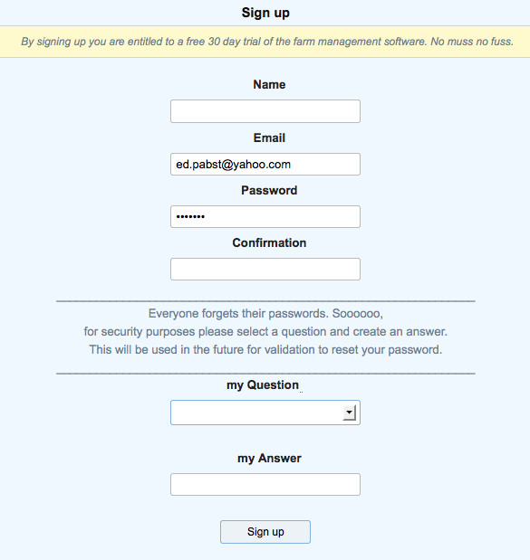

Enter your name, password and security questions and you will be established as a user. Once you are a user you have your own iFarmService account and can begin to define your farm business. This account will be valid for 30 days. In addition, you become an instant member of the iFarm social network. Here you can share ideas and experiences with other farmers. When you are finished working you can log out. To “log in” after that just enter your email and password.

After that, if you wish to continue with iFarmService, you will need to set up a subscription for $199 per year. You can manage your subscription status in the “mySettings” feature which is both on the header options and the “utilities” menu.

Once you have an account established you will just need to sign in , in the future, when you wish to use the system. The system is very secure and your data is protected based on current industry security techniques.

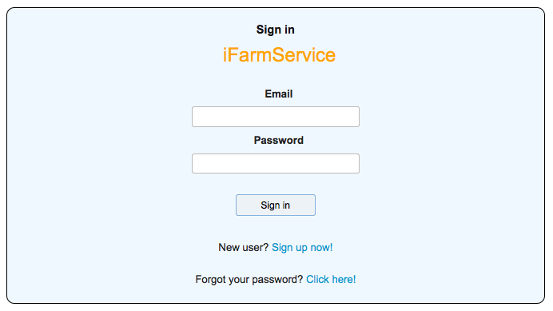

If, by chance, you forget your password you can change it by clicking on the ‘click here’ link and answering your security question. (Oh yeah! That’s why they asked me for a security question).

Now let’s get down to business.

All features can be accessed from the menu bar at the top of each page.

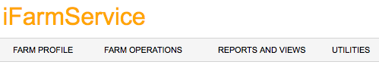

The first thing you have to do is to define your basic **profile information** which includes people, businesses, farms, fields, crops and crop plans. It’s a little bit of work and planning but once it’s done, the system is extremely easy to use.

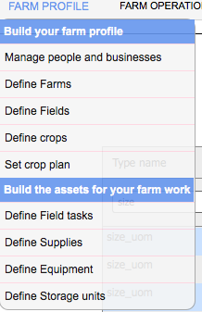

**Define People and businesses** (which we refer to as “parties”)

In party definition you define the name, address, email, phone and roles of the people and businesses that you do business with. For labor related parties you can define labor rates. For farm management businesses you can define the rate that you charge for labor. For customers you can define shipping addresses that differ from the billing address. Pretty simple.

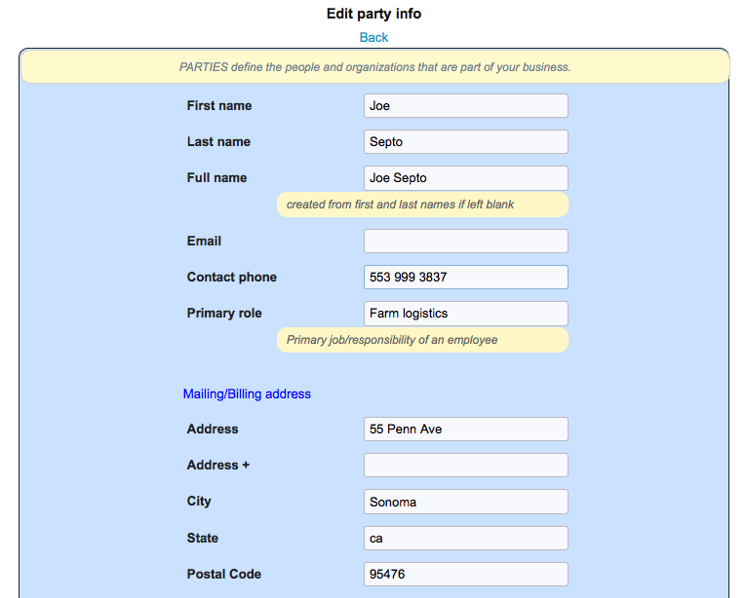

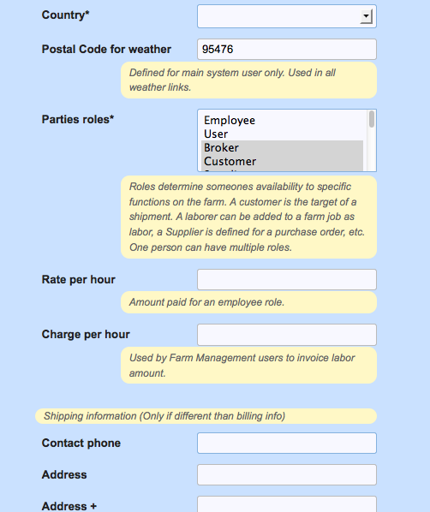

Party roles are important. They are used to expose your people and businesses in other parts of the application. A single party can have multiple roles.

**User** - owner/user of the iFarm Service account   
**Employee** - people who are employed by the farm. (supervisor/foreman) will be exposed as labor for a farm job.   
**Labor machine** - people who operate farm machinery will be exposed as labor for a farm job.  
**Labor non machine** - people who perform basic work on the farm will be exposed as labor for a farm job.   
**Supplier** - business/person who supplies are purchased from are exposed on a purchase order.   
**Broker** - Sales agents are recorded on shipments for commission purposes.   
**Customer** - Business who harvested crops are sold and shipped to are exposed on shipments.  
**Landlord** - Land owner if fields are leased is exposed in Field definition.  
**Client** - Farmers that a farm management enterprise provides service to are exposed in Field definition.   
**Billing source** - Assigned to each farm for invoice billing information in Farm definition.  
**Test labs** - organizations that perform soil tests and crop quality tests. Defined in Field definition

**Define Farms**

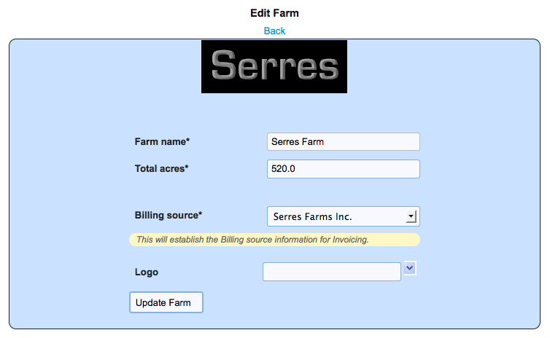

and **Farm expenses** - these will be used in your profitability reports for that farm.

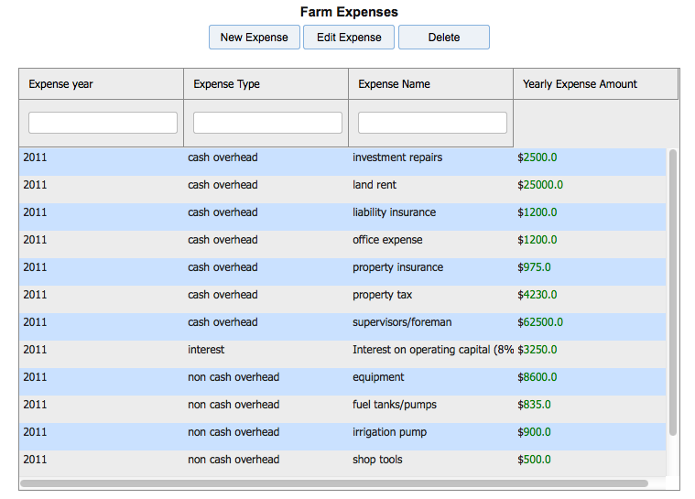

**Define Fields**

Within the field definition you can geocode your field location and then map the boundaries of the field. Farm jobs are assigned to specific fields. A field can be any size and is useful in understanding yield of specific areas.

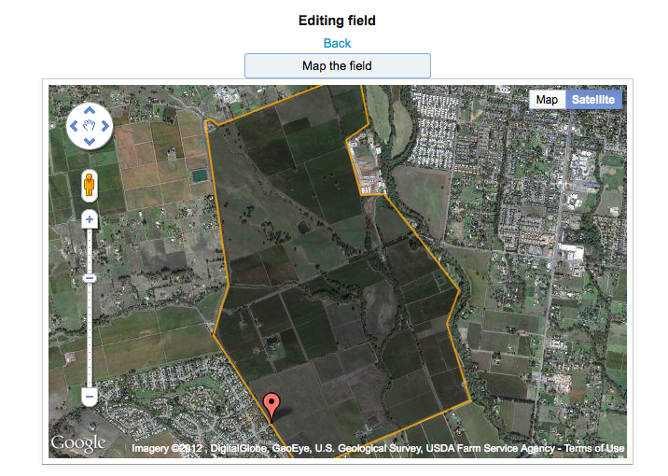

**Field Mapping**

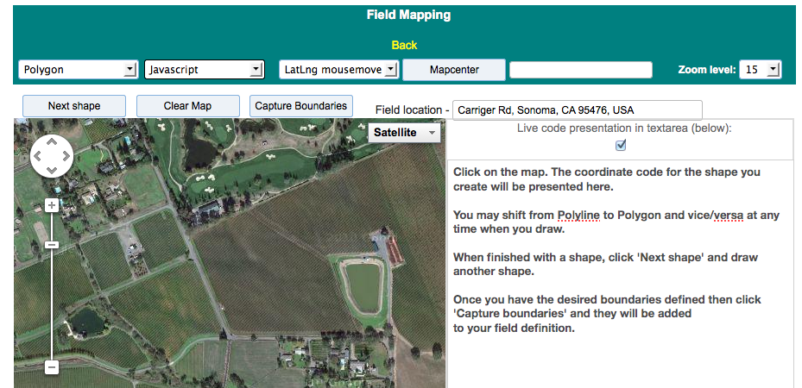

Your field location (map location) should be in proximity to the fields. From there you draw the boundaries as desired with the field mapping tool. The boundaries are then carried in to your field definition as shown above.

**Field information**

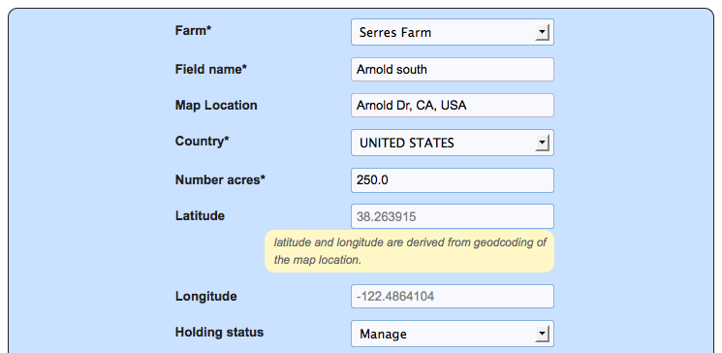

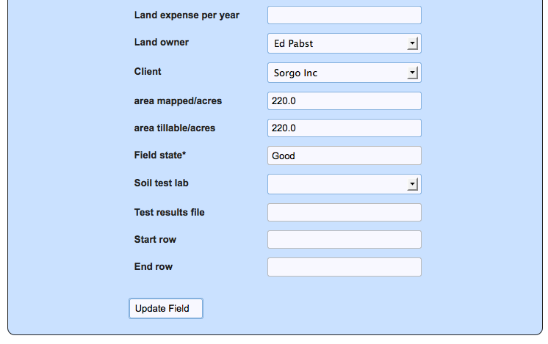

Fields belong to farms. You can assign as many fields as you wish to a farm. The finer your field definition is, the richer your crop yield information will be.

Holding status defines the management characteristics for the field.

**Owned** – the owner of the field. Generally, means that you are an individual farmer.

**Manage** - This states that the user is a farm management service and this is one field being managed. This is used to generate reports for farm management companies.

**Leased** – states that you are leasing the field from a Landord . In this case, you may be paying rent and/or compensating the landlord with a fixed amount of crop per acre.

**Share Crop** – states that the landlord allows the tenant to use the farm for a fixed percent of the overall harvest.

For holding status ‘Leased’ and ‘Share crop’ you must define the landlord in party definition and select them for this field.

For holding status ‘Manage’ you must define the client in party definition and select them for this field.

**Define Crops**

You can define as many crops as you like. Crops can be co-mingled by field.

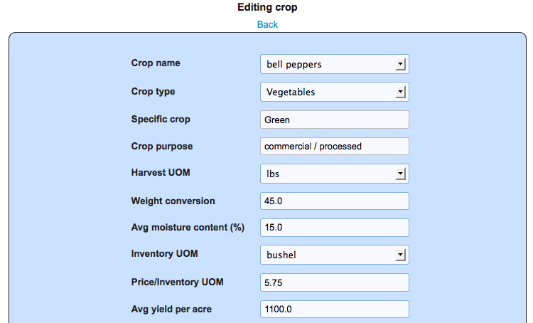

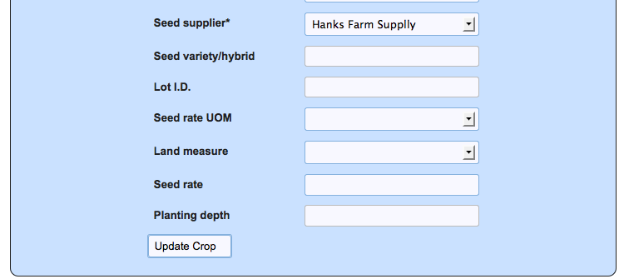

Harvest unit of measure establishes the unit that will be used during harvest to capture yield. Normally, this will be weight but is not restricted to lbs. It could be defined as tons, kilos etc. The inventory unit of measure establishes what unit inventory will be stored and sold in. The weight conversion converts the harvest UOM to the inventory UOM.

Price is for the inventory unit of measure. This is used on shipments and for invoicing purposes if no contract price is established.

Average yield per acre is the historical or industry standard for a specific crop yield. It is the target to measure your crop yield against.

Most other fields are information for the specific crop.

**Define Crop Plan**

A crop plan establishes your intention of growing a particular crop for a season/year.

Crop plans are entered into farm jobs to gather costs and are harvested through scale tickets to establish yield and inventory.

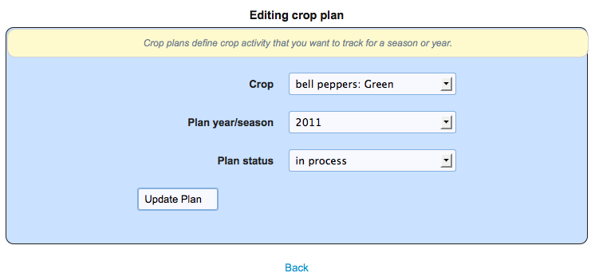

That pretty much completes our farm profile definition. Next, we move on to defining the assets that will be used in Farm jobs.

**Building the Assets for your Farm Work**

Assets are the components that are used to build a farm job. They will establish a job cost basis for labor, supplies and equipment.

Assets include Field tasks (work), supplies, equipment and storage units.

They additionally include Labor which was previously discussed in Party definition.

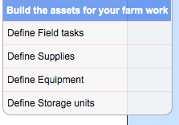

**Define Field Tasks - (field task identify specific work)**

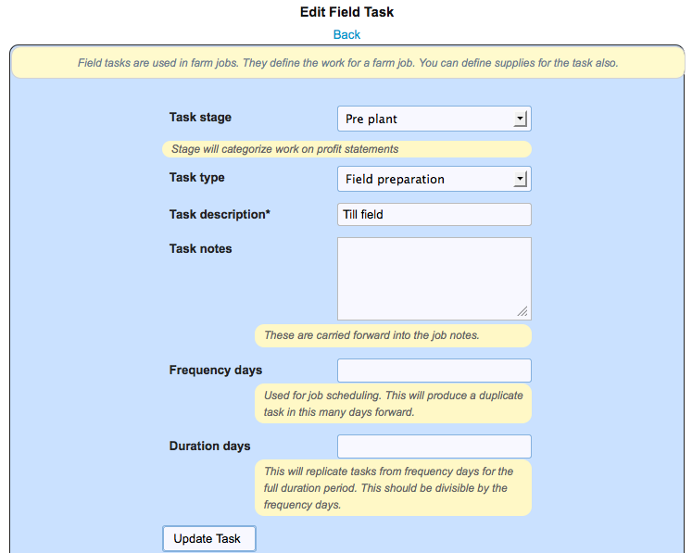

In addition, you can define the supplies that will be used in a field task. These will be carried into the farm job when the task is assigned to the job.

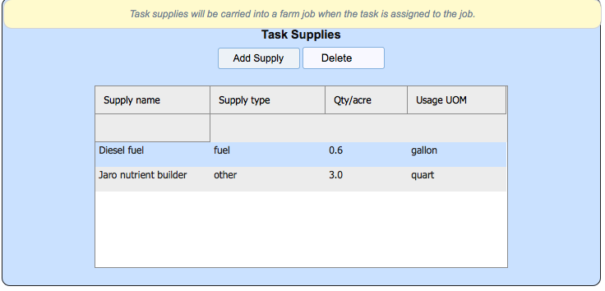

**Define Supplies**

Supplies are the components used in farm jobs. They are defined with a usage rate per acre that will generate an overall cost based on the acreage of the farm job.

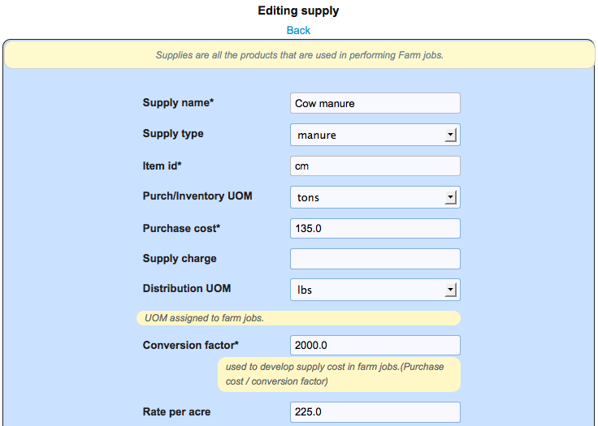

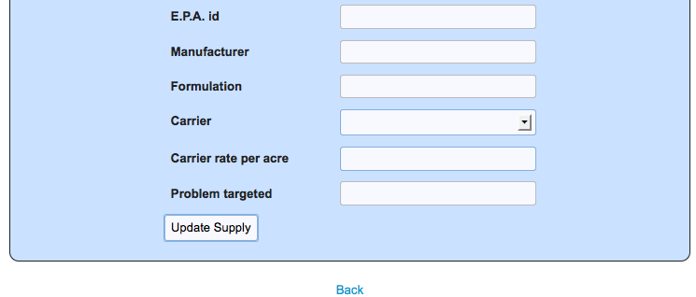

**Define Equipment**

Equipment is the machinery that is used in a farm job. You can define an hourly usage cost that will be used in the farm job to develop an equipment cost. For Farm mgmt you can specify a charge rate. You can also upload images of the equipment.

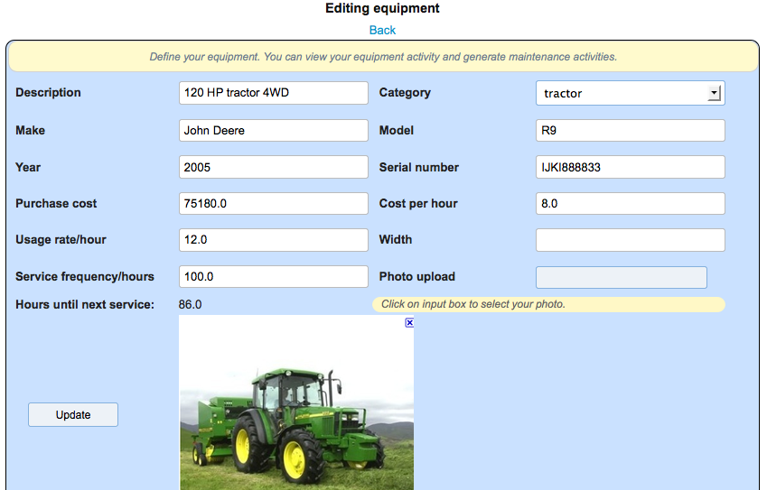

In addition, you can view the farm job activity history of the equipment and track the maintenance activity. By establishing a service frequency period you will always know how many hours until the next required service.

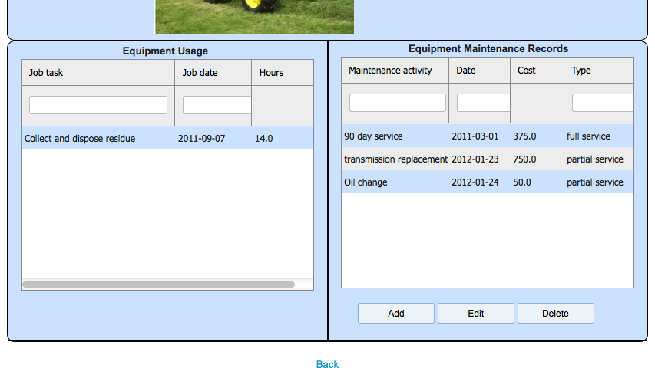

**Define storage units**

Storage units are defined as either physical or logical areas where both supply and crop inventory can be located.

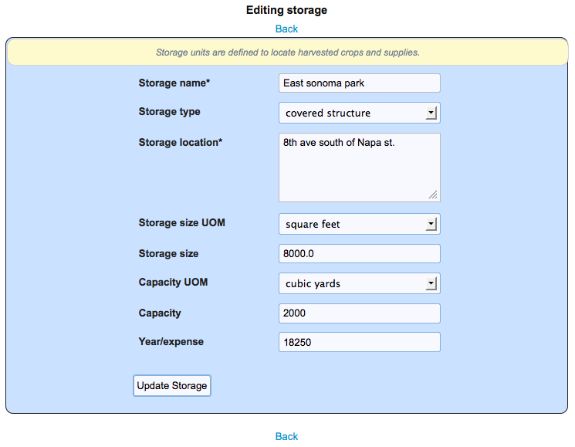

Well that’s it for defining your job assets. Next we move on to the operational features of running a farm.

**Farm Operations**

Farm operations are all the features used to run the farm. With them you can schedule, plan, execute and monitor the workings of the farm.

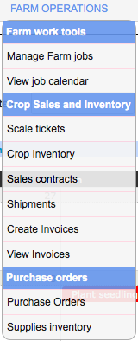

**Farm jobs**

Farm jobs define the various work tasks and costs for running your farm. Farm jobs specify the specific work, field and crop plan associated with the job. Farm jobs have three status’.

Plan

In Process

Job Complete

Therefore, you can estimate costs based on the ‘Plan’ status and capture your actual costs for ‘Job Complete’ status work. After a job’s status is set to ‘Job Complete’, a final cost is developed and the job can no longer be changed.

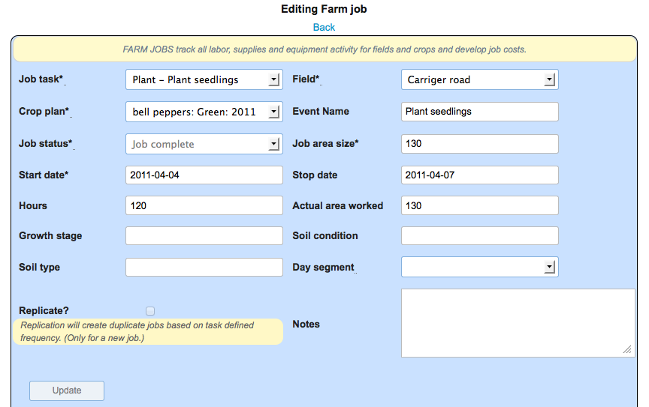

The farm job is linked to a calendar event. The event name is used in the calendar.

The area size for the job drives the cost development for associated supplies. The actual area worked is used for final costing. The job hours drive the cost development for labor and supplies. The start and stop dates set the job dates in the calendar.

In addition, if the job task has an associated frequency interval then the specific farm job can be replicated when the job is first defined. In that case, if supplies were also defined for the job task then they too would be replicated with the new jobs. This is useful when you have repetitive tasks like weekly irrigation that you want to develop costs for.

**Farm job costs**

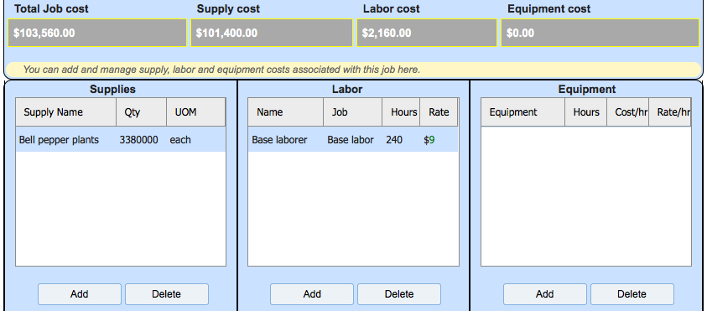

You can define the supplies, labor and equipment for the job. The specific costs may be entered directly or they can be carried in the from the supply, labor and equipment definitions

**Supplies** – have a cost and usage qty per acre that is extended by the job area size.

**Labor** - party definition contains labor rates that are extended by job hours.

**Equipment** – has a usage cost that is extended by job hours.

Any of these values can be overridden. Overrides can occur inline in the grids.

Assignment of specific equipment to completed jobs records that activity for maintenance schedules.

**Job Calendar**

The job calendar allows you to view your work schedule from an orderly and clear calendar view. The job can be selected and maintained from the calendar just by clicking on the job. The changes you make will be reflected in the calendar. By putting the cursor over the job a full job description is presented. The color codes represent different job status’.

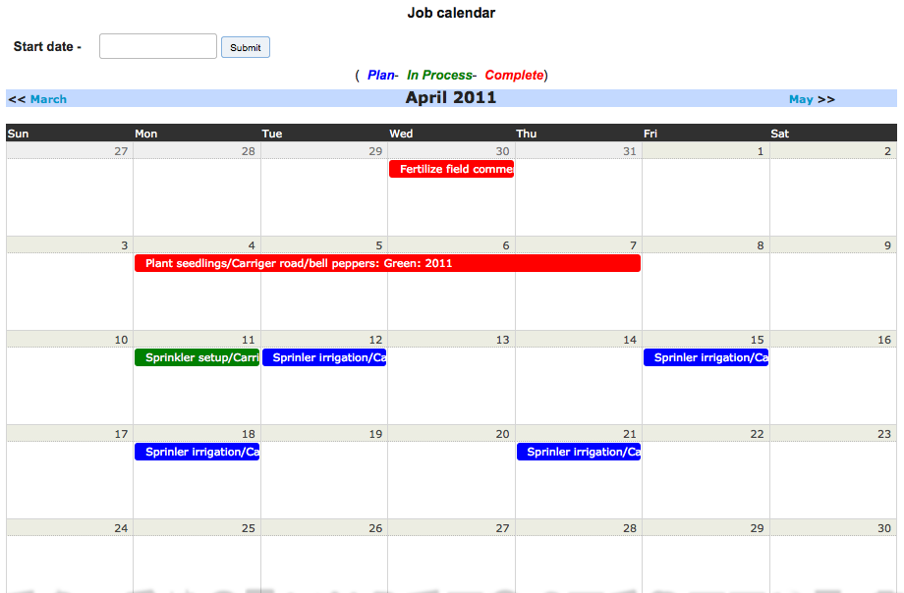

**Scale tickets**

Scale tickets record the weight of the harvested crops. A scale ticket creates an inventory record at a specific storage location. You can choose to record inventory in a consolidated fashion or you can maintain scale ticket integrity in inventory. This is useful when you want to ship the full scaleticket to a customer.

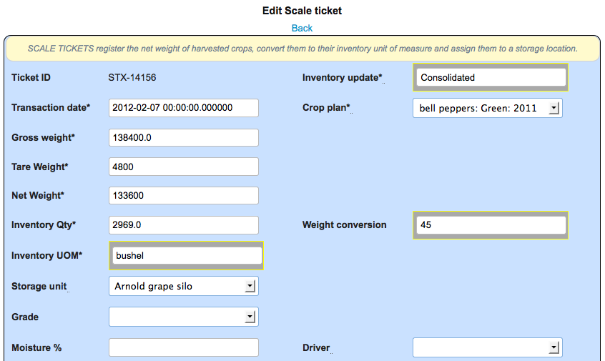

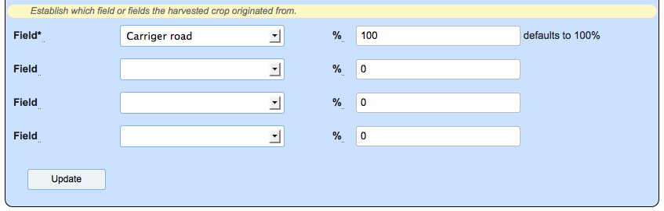

Crop definition contains unit of measures for harvest amounts and inventory (sales) amounts. The harvest amount, usually weight, is converted to the inventory measure based on a weight conversion in supply definition.

Inventory amount is directed to a storage location. Moisture % is recorded for certain crops.

The field or fields that the harvested crop originated from is recorded. This allows for traceability.

**Crop inventory**

Crop inventory is created from scale tickets. Inventory is recorded by location and grade. Inventory can be re-graded and transferred between locations. Locations can be defined for damage or any other purpose.

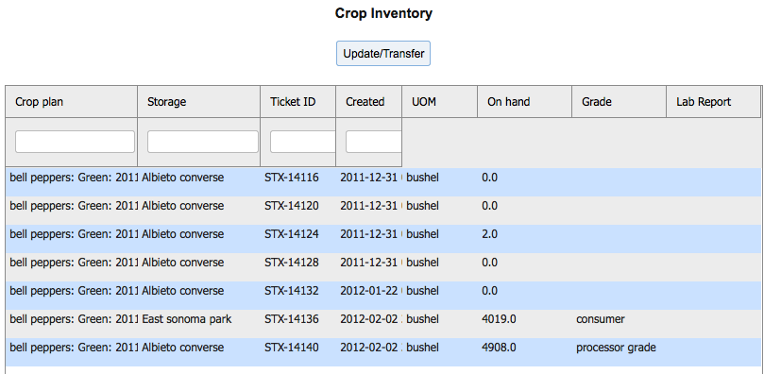

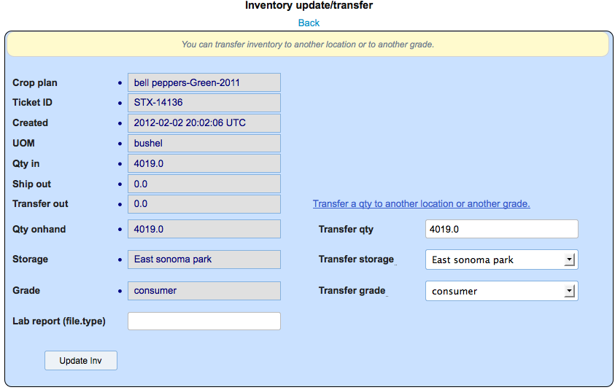

Inventory can be viewed in detail.

Qty in – from scale ticket or transfer from another location

Ship out- quantity assigned to a customer shipment

Transfer out – quantity moved to another location or grade

Qty on hand – quantity currently available in that location

You can transfer and/or re-grade inventory. If you leave the transfer qty the same and change the transfer storage location and/or the transfer grade, the inventory will be moved accordingly. If you change the transfer qty (only less than onhand) the partial qty will be moved accordingly and the remainder will remain in the existing inventory record.

**Sales Contracts**

A sales contract is an agreement with a customer to reserve crop inventory and sell it in the future (at harvest) at a specific price. When a shipment is made, the contract can be referenced and the contract price will be used on the shipment and for invoicing.

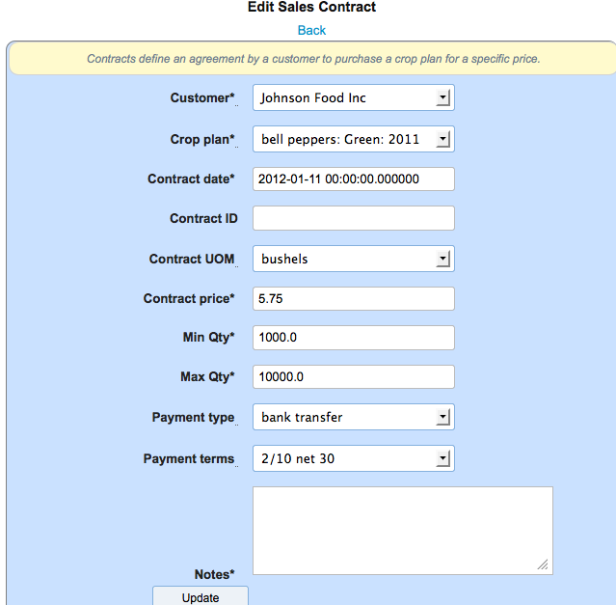

**Shipments**

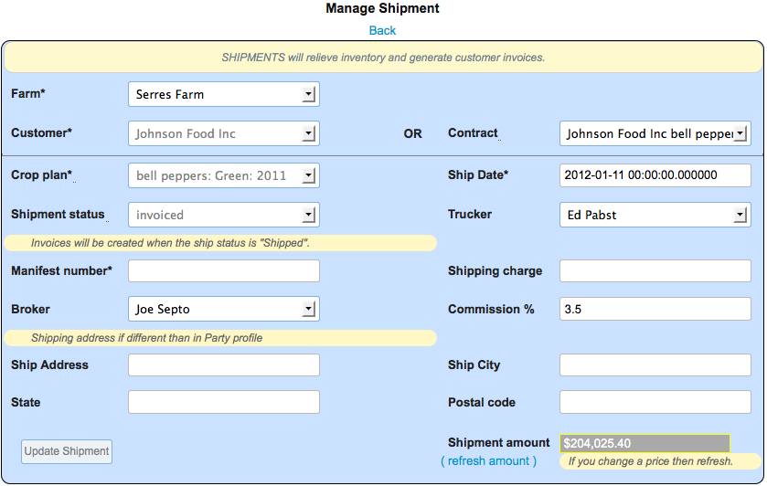

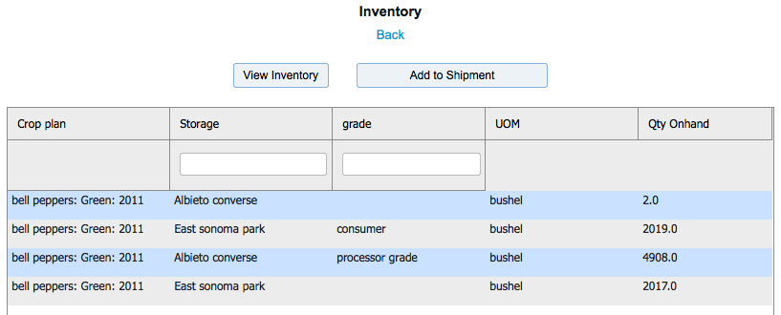

A shipment is a sale of inventory to a customer. It can originate from a sales contract or just be direct to a customer. Price is captured either from the contract or the established crop price in crop definition. Price can be overridden in the shipment detail grid. Shipment status can be defined as either new or shipped. If the shipment is flagged as shipped it becomes eligible for invoicing. When the shipment has been invoiced the status is set to ‘invoiced’ and the shipment can no longer be changed.

A shipping charge can be assessed to the customer and will be invoiced. A sales agent (broker) and his commission rate can be defined. An alternate shipping address can be defined.

**Shipping Inventory**

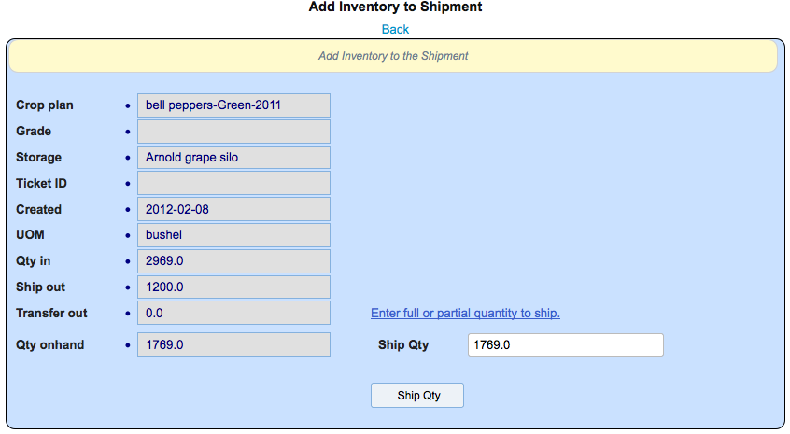

**Invoices**

Invoicing is a two step process. First you must generate the invoices and second you must print them. Invoice generation will look for all shipments whose status is ‘shipped’, create the invoice from the shipment information and then flag the shipment as ‘invoiced. When the invoice is created it’s status will be set to ‘new’. You can run the process for a specific customer and/or shipped date range.

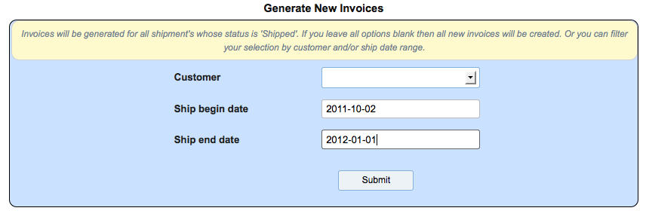

You can view the invoices using the ‘view invoice’ option on the farm operations menu. You can select an invoice and change any information other than financial and product information. I

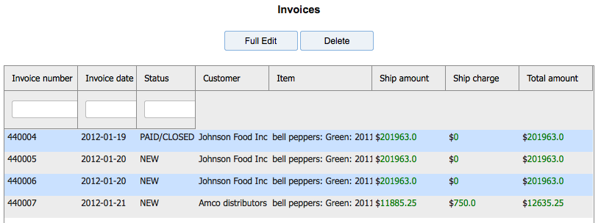

You can filter the print of invoices by customer and date range. You can print a single invoice by number. Or, you can reprint invoices when you want. Invoice print will look for all invoices whose status is ‘new’. When you print an invoice it’s status is set to ‘printed’. If you set the reprint option to ‘yes’ then the process will only look for invoices whose status is NOT ‘new’.

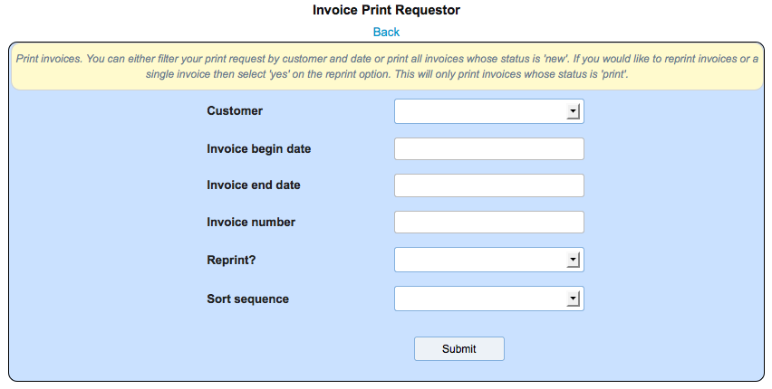

Below is an example of a printed invoice.

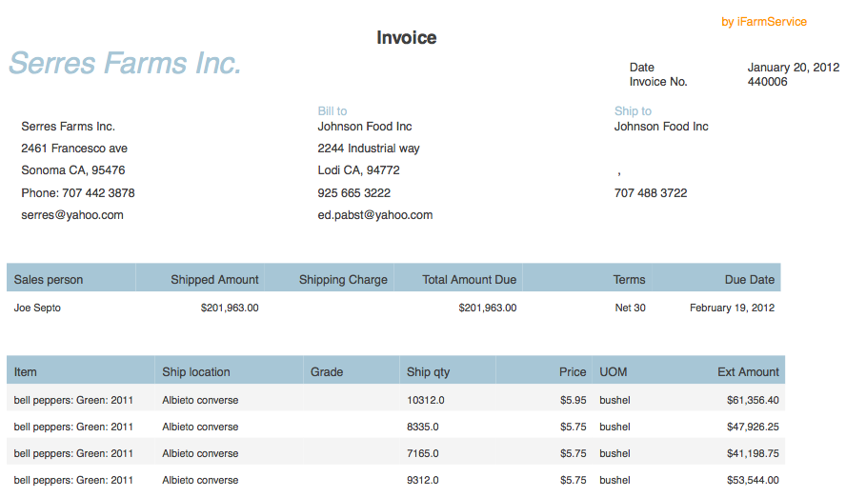

**Purchase orders**

Purchase orders are used to acquire your supplies inventory. They are written to a defined supplier (from party definition). For the line items, the supply cost and unit of measure is taken from the supply definition but can be overridden when the PO line is created.

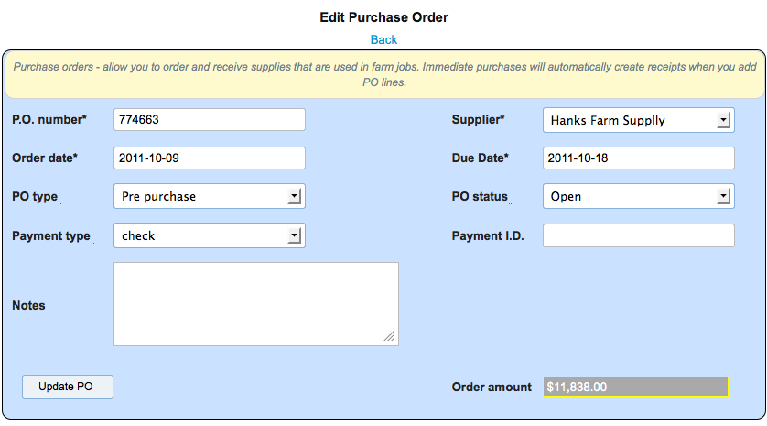

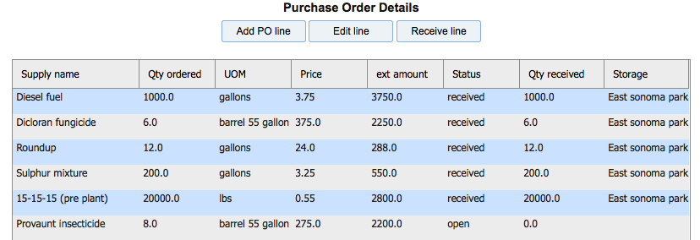

If you set the PO type to ‘immediate’ and set the PO status to ‘received’ the lines items will be received into inventory as they are added. This is a convenient way to establish your supplies inventory as a starting point or if you are adding a PO after the fact. Otherwise, as is the case with a ‘pre purchase’ PO you select to receive the lines items at a later time by clicking the Receive line button.

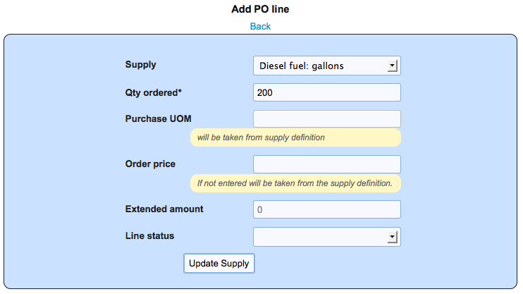

**Add/edit a PO line**

Select the desired supply from your supply list. Enter the quantity desired. Purchase unit of measure is always taken from the supply definition. Price can be entered or will be taken from the supply definition.

**Purchase receipt**

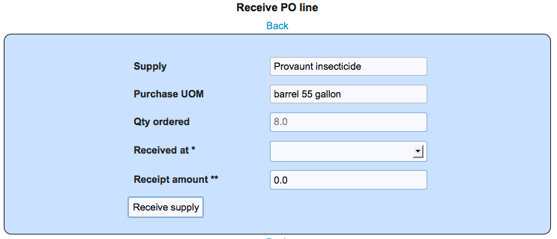

Enter the quantity received. You can have multiple receipts for a line. Also, enter the storage location where the supplies will be located. A receipt will create a supply inventory record in the storage location.

**Supply inventory**

Supply inventory records are created when you receive a purchase order line. The lines are received into storage locations. For each supply/storage location, we maintain an inventory value and an average cost for the supply.

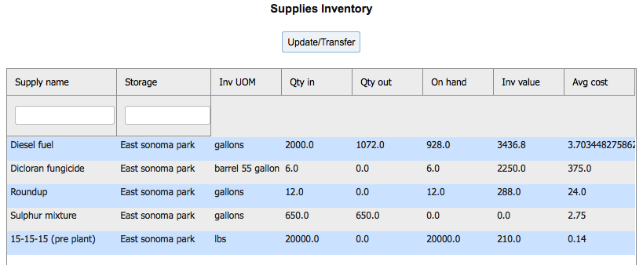

You can transfer and adjust your supply inventory . You can transfer all or part to another storage location. Or you can adjust the inventory for your needs. Qty in shows the PO receipt amounts and positive quantity adjustments. Qty out reflects, supply usage, transfers and negative adjustments. On hand reflects the current inventory balance in that location. Supply inventory is relieved when a farm job, that used that supply, is completed

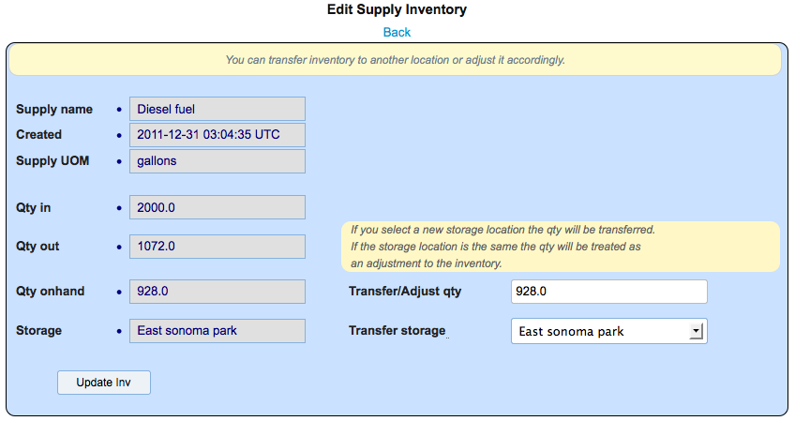

**Reports**

The system comes with various reports to help you manage your farm. The key reports are

**Farm job report** – which assists is monitoring the status and cost of the work occurring on the farm. You can filter the report in several ways. You always enter a date range for the work. Additionally you can sort the data in the report by

Crop

Field

Task

Job Status

Date

Job status is useful when you are maintaining your data for planning purposes. You can select for planned tasks or completed tasks exclusively. Or, view all status’.

**Requestor**

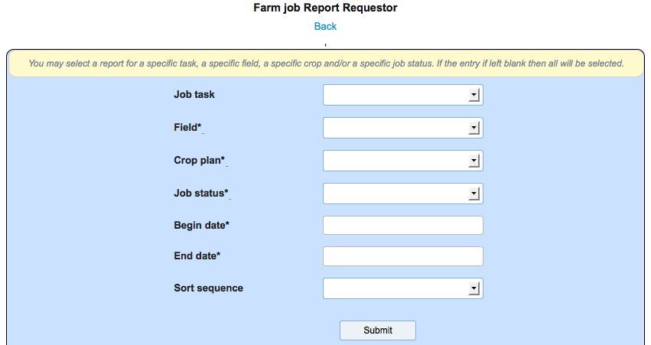

**Report**

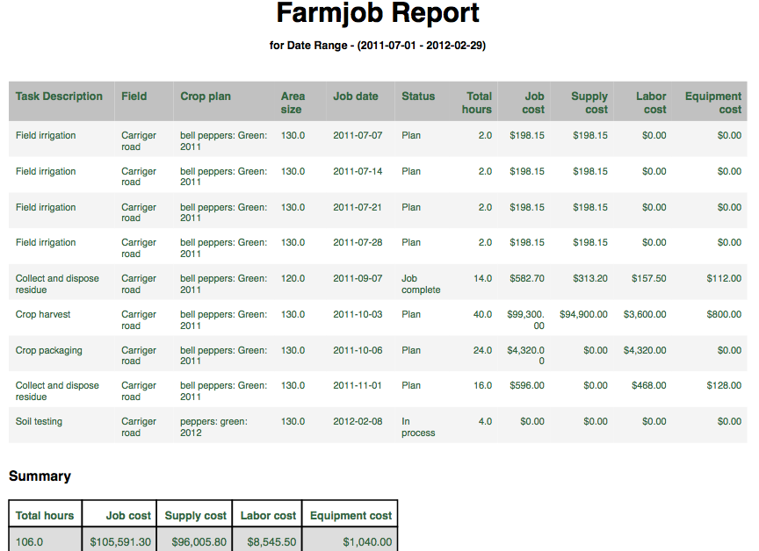

**Profitability reports** – which come in several flavors

**Cost analysis**

**Profitability analysis**

**Cost analysis by month**

These are all selected through a single requestor for “Profitability Reports”

As with the Jobs report the requestor gives you a lot a flexibility.

**Requestor**

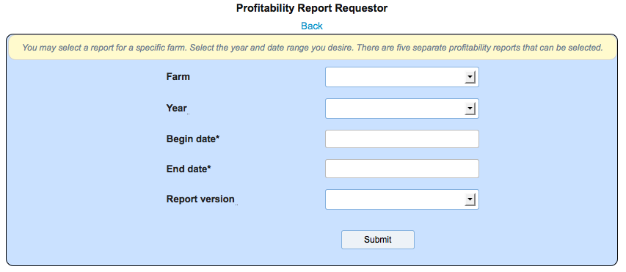

You must select the farm and plan year to produce your report. You must always enter a date range of activity. Then select the specific report version.

**Cost Analysis**

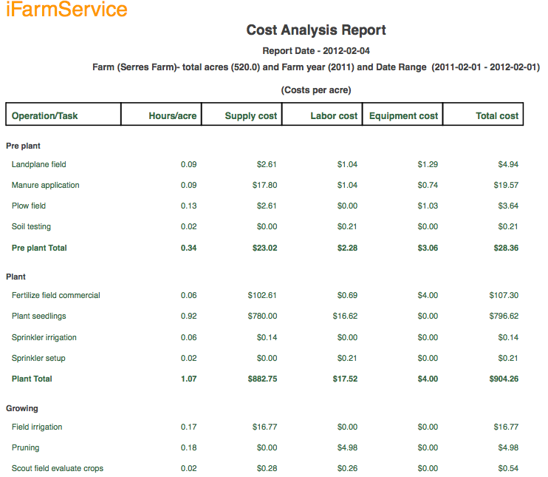

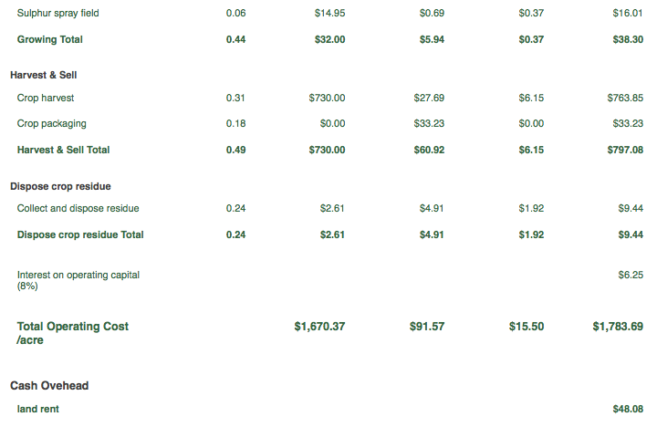

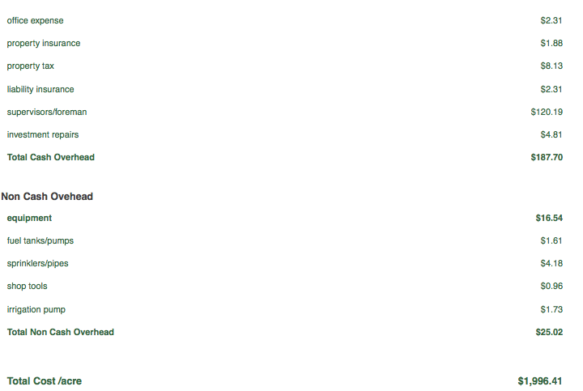

**Profitability Analysis**

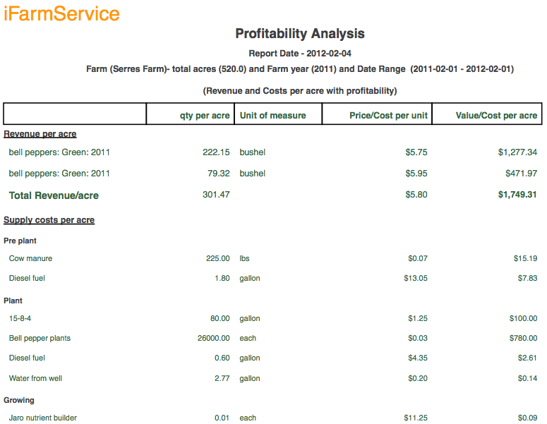

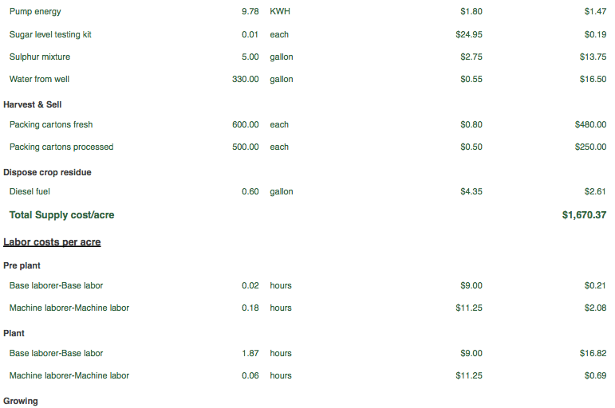

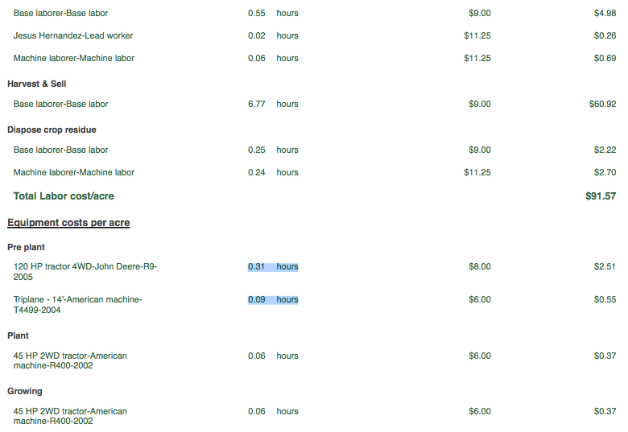

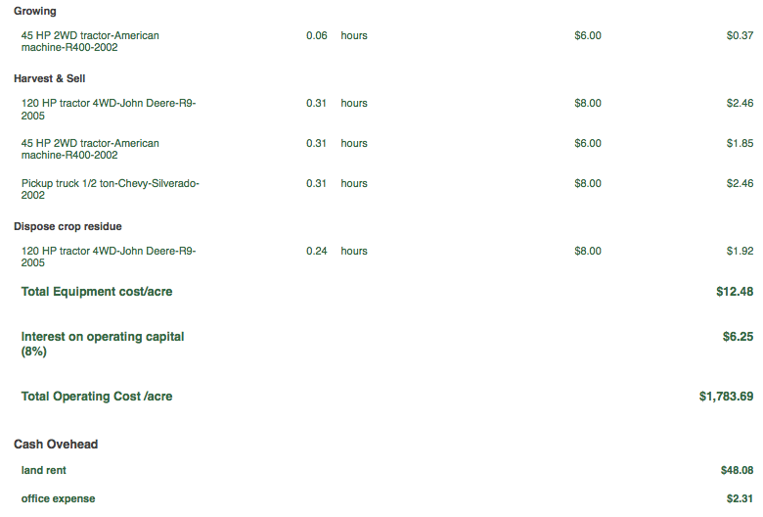



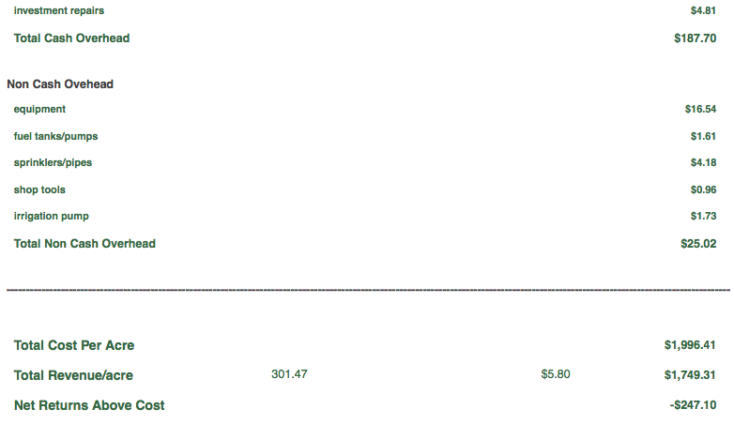



**Farm Social network**

The iFarmService social network allows all registered users (farmers) to exchange thoughts, ideas, inspiration and business information. Each farmer can post any information they wish and it becomes visible to other farmers. A farmer can then select specific farmers to join their community which will weave a continuous idea and information flow for your personal community.

**Farm community**

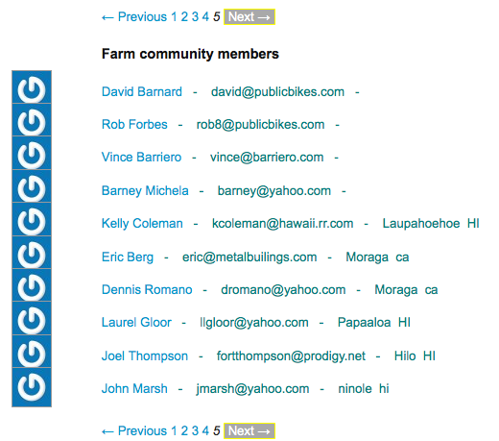

When you view the farm community you can select an individual farmer, click on their name, and view all of there comments. If you like what they have to say you click the “Follow” button and they will be come part of your personal community.

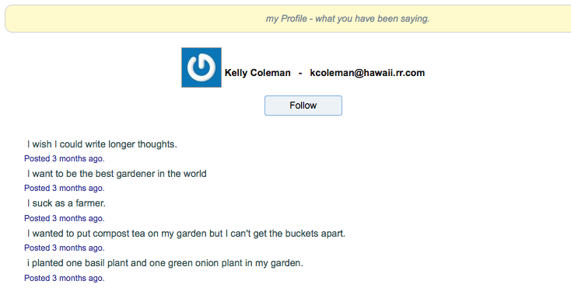

**My community**

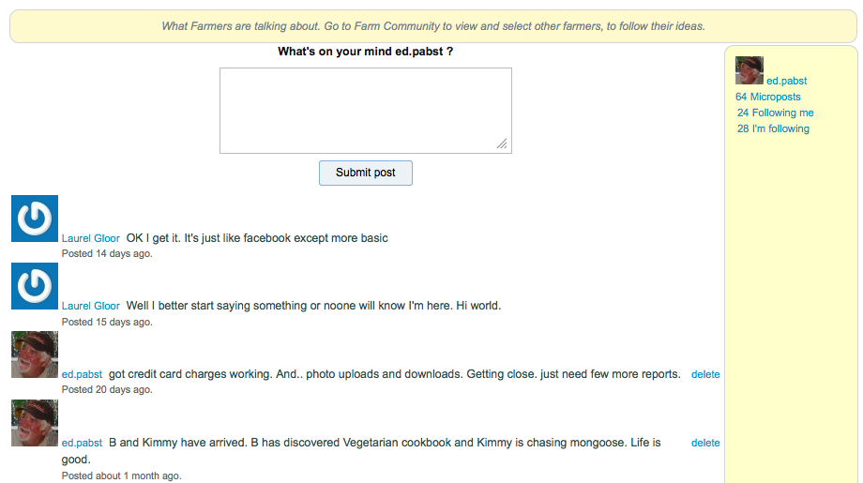

Your home page is your community page. Here you can post your personal comments and you can see all of your comments interwoven by date and time with the comments of other farmers that you “Follow”. The panel on the right contains your community statistics. Number of farmers that are following you and number of farmers that you are following. You can click on the statictics to view the individual farmers. From there you can choose to “Follow” or “Unfollow” any given farmer.